Name : Ragini Singh

Cohort: Jensen Haung

Roll Number: 150096724023

Survey App

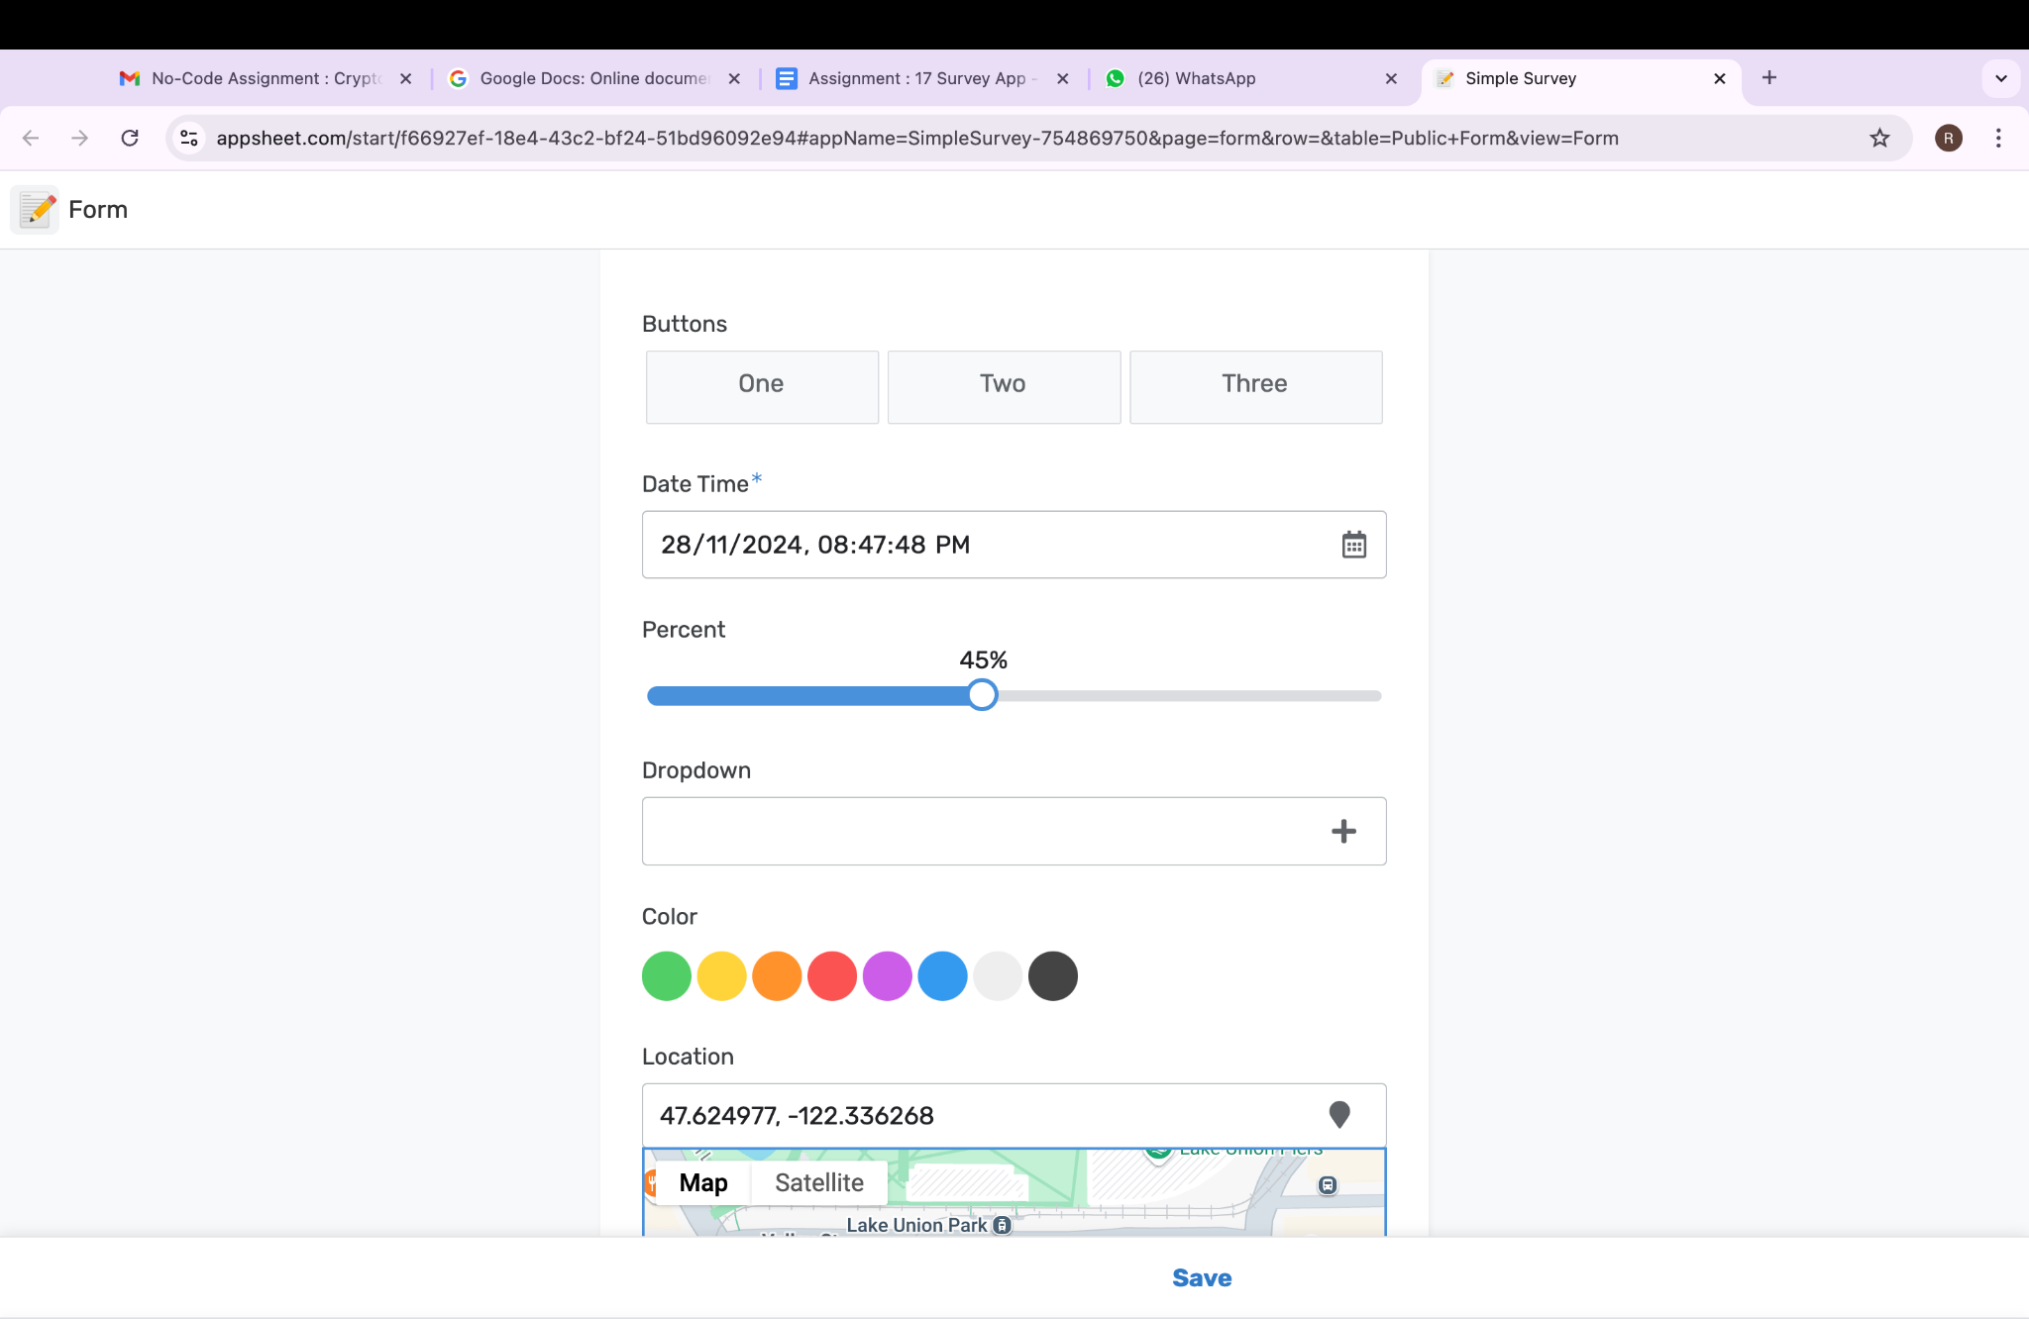

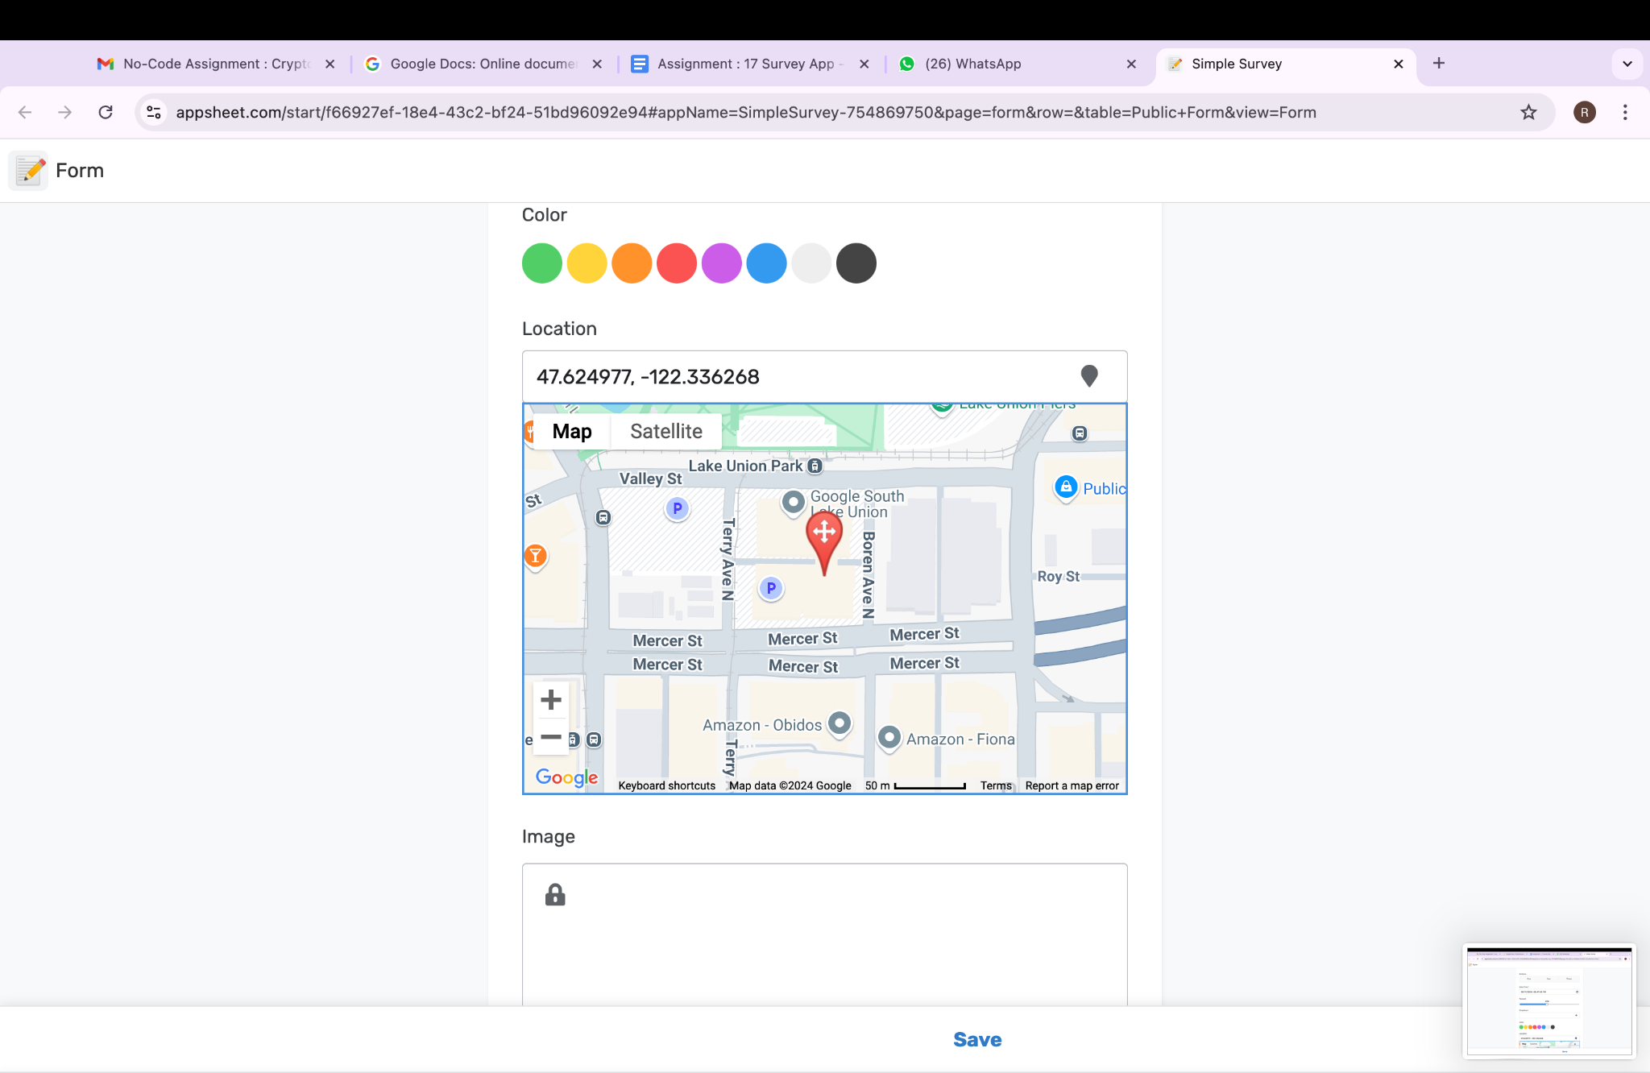

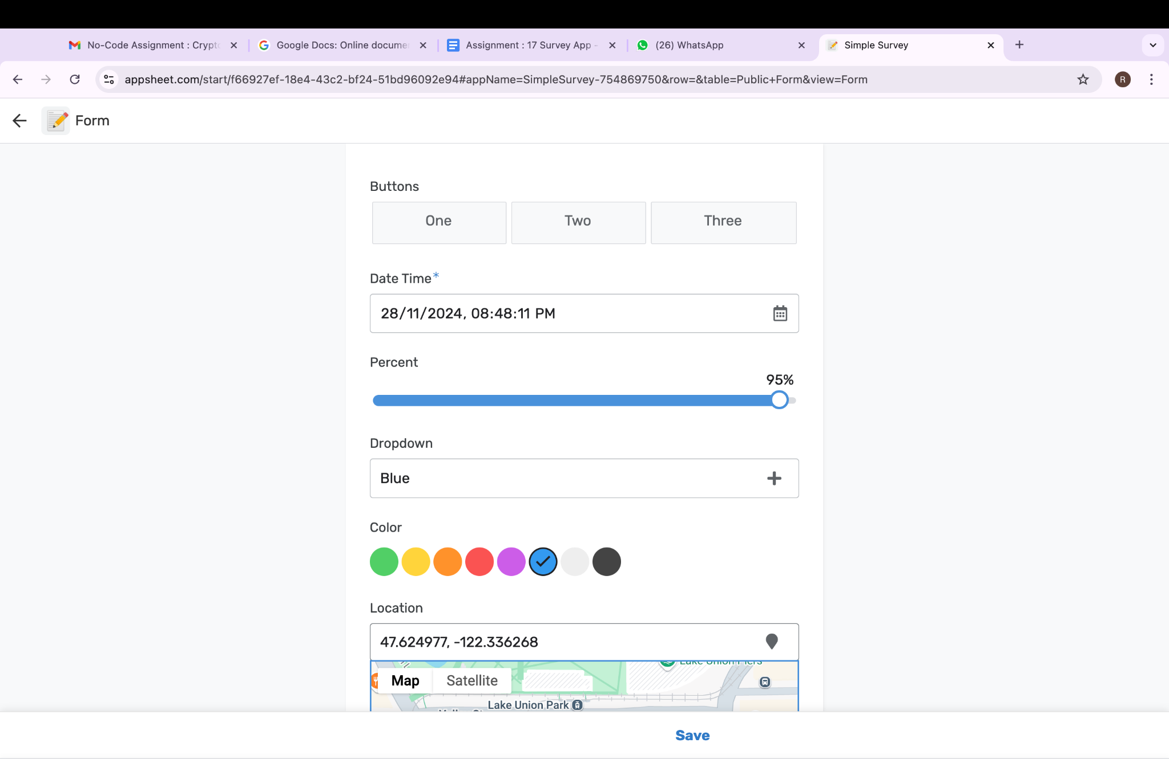

https://www.appsheet.com/start/f66927ef-18e4-43c2-bf24-51bd96092e94